Watch Windows
You can say it is an investigation window. After breakpoint has been hit, the next thing you want to do is to investigate the current object and variables values. When you mouse hover on the variable, it shows the information as a data tip which you can expand, pin, import which I have already explained. There are various types of watch windows like Autos, Local, etc. Let's have a look into their details.

Locals
It automatically displays the list of variables within the scope of current methods. If your debugger currently hits a particular breakpoint and if you open the "Autos" window, it will show you the current scope object variable along with the value.
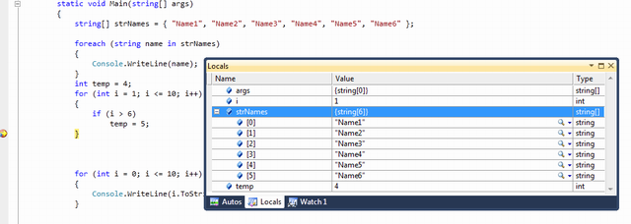
Figure: Local Variables

Autos
These variables are automatically detect by the VS debugger during the debugging. Visual Studio determines which objects or variables are important for the current code statement and based on that, it lists down the "Autos" variable. Shortcut key for the Autos Variable is "Ctrl + D + A".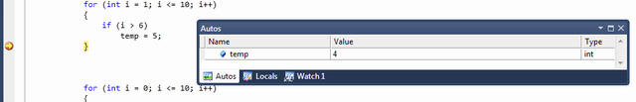
Figure: Autos - Ctrl+D, A

Watch
Watch windows are used for adding variables as per requirement. It displays variables that you have added. You can add as many variables as you want into the watch window. To add variables in the watch window, you need to "Right Click" on variable and then select "Add To Watch".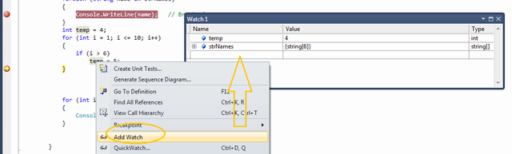
Figure: Autos - Ctrl+D, W
You can also use Drag and Drop to add variables in watch windows. If you want to delete any variable from watch window, just right click on that variable and select "Delete Watch". From the debug window, you can also edit the variable value at run time.
There are 4 different watch windows available which you can use parallelly.
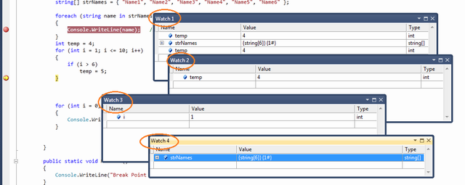
Figure: Multiple Watch Window
If any of the row variables of the above window holds the object instance, you can have a "+" symbol with the variable to explore the properties and member of that object variable.
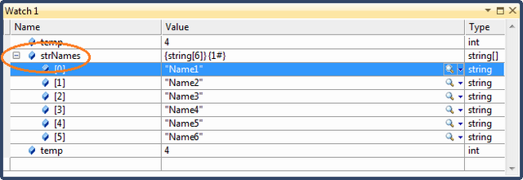
Figure: Expanding Watched Variable

int main()
{
myclass m;
int i;
m.disp1(m);
m.disp2();
for(i=0;i<5;i++)
{
cout<<i<<endl;
}
cout<<"for loop over"<<endl;
cout<<i<<endl;
return 0;
}

In the above code in debugging mode press F10
Cursor will come to the first statement of “main”
Check “Locals” window, you can see both “m” and “i”
But if u look a the “Autos” window u can’t see any variable .
It is because, “Autos” window displays those variables which are required for the current statement.
Now press F10 again to place a pointer on “myclass m” statement.
Check “Locals” window , you will get “m” and “I”
Check “Autos” window, you will get only “m”

Note:- inside “Autos” and “Locals” u can change the value of a variable. These two windows are in sync with each other.

